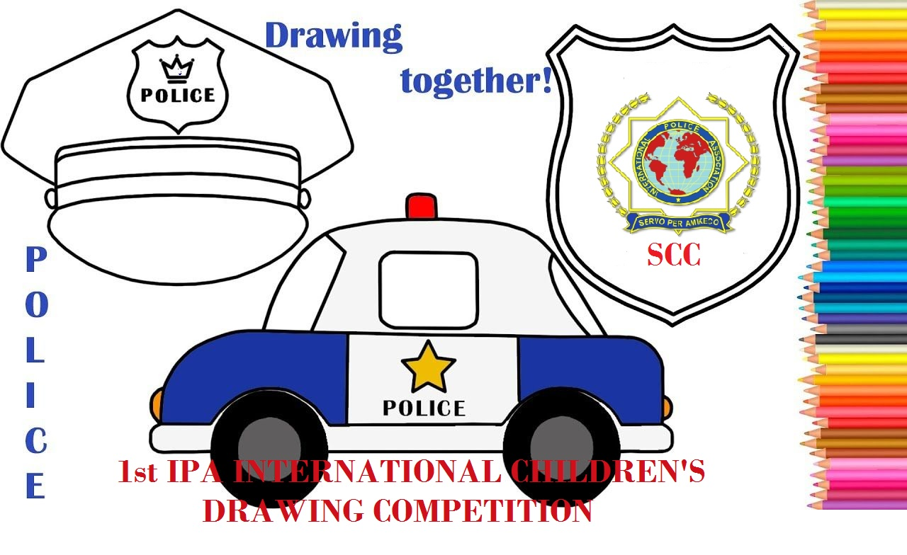 | INTERNATIONAL POLICE ASSOCIATION  INTERNATIONAL EXECUTIVE BOARD  SOCIO-CULTURAL COMMISSION  1st IPA INTERNATIONAL CHILDREN’S  DRAWING COMPETITION
ENTRY FORM
Member’s name:
Member’s IPA card no:
Relation with the child:
Child’s name:
Child’s date of birth:
Section:
Topics of the painting: (please tick)
Police at work
Police and animals
Children of the world
GUARDIAN’S CONTACT DETAILS
Address:
Mobile tel. number:
e-mail:
By signing below, I hereby declare that the above information is true and by posting this entry I have read and accept the terms of the competition.

DATE………….PLACE…………. SIGNATURE…………..
ENTRIES THAT WILL BE RECEIVED LATER THAN 31-8-2020 WILL BE REJECTED
Please scan and sign this form and send it together with the painting scanned, to ipa.icpc@gmail.com

